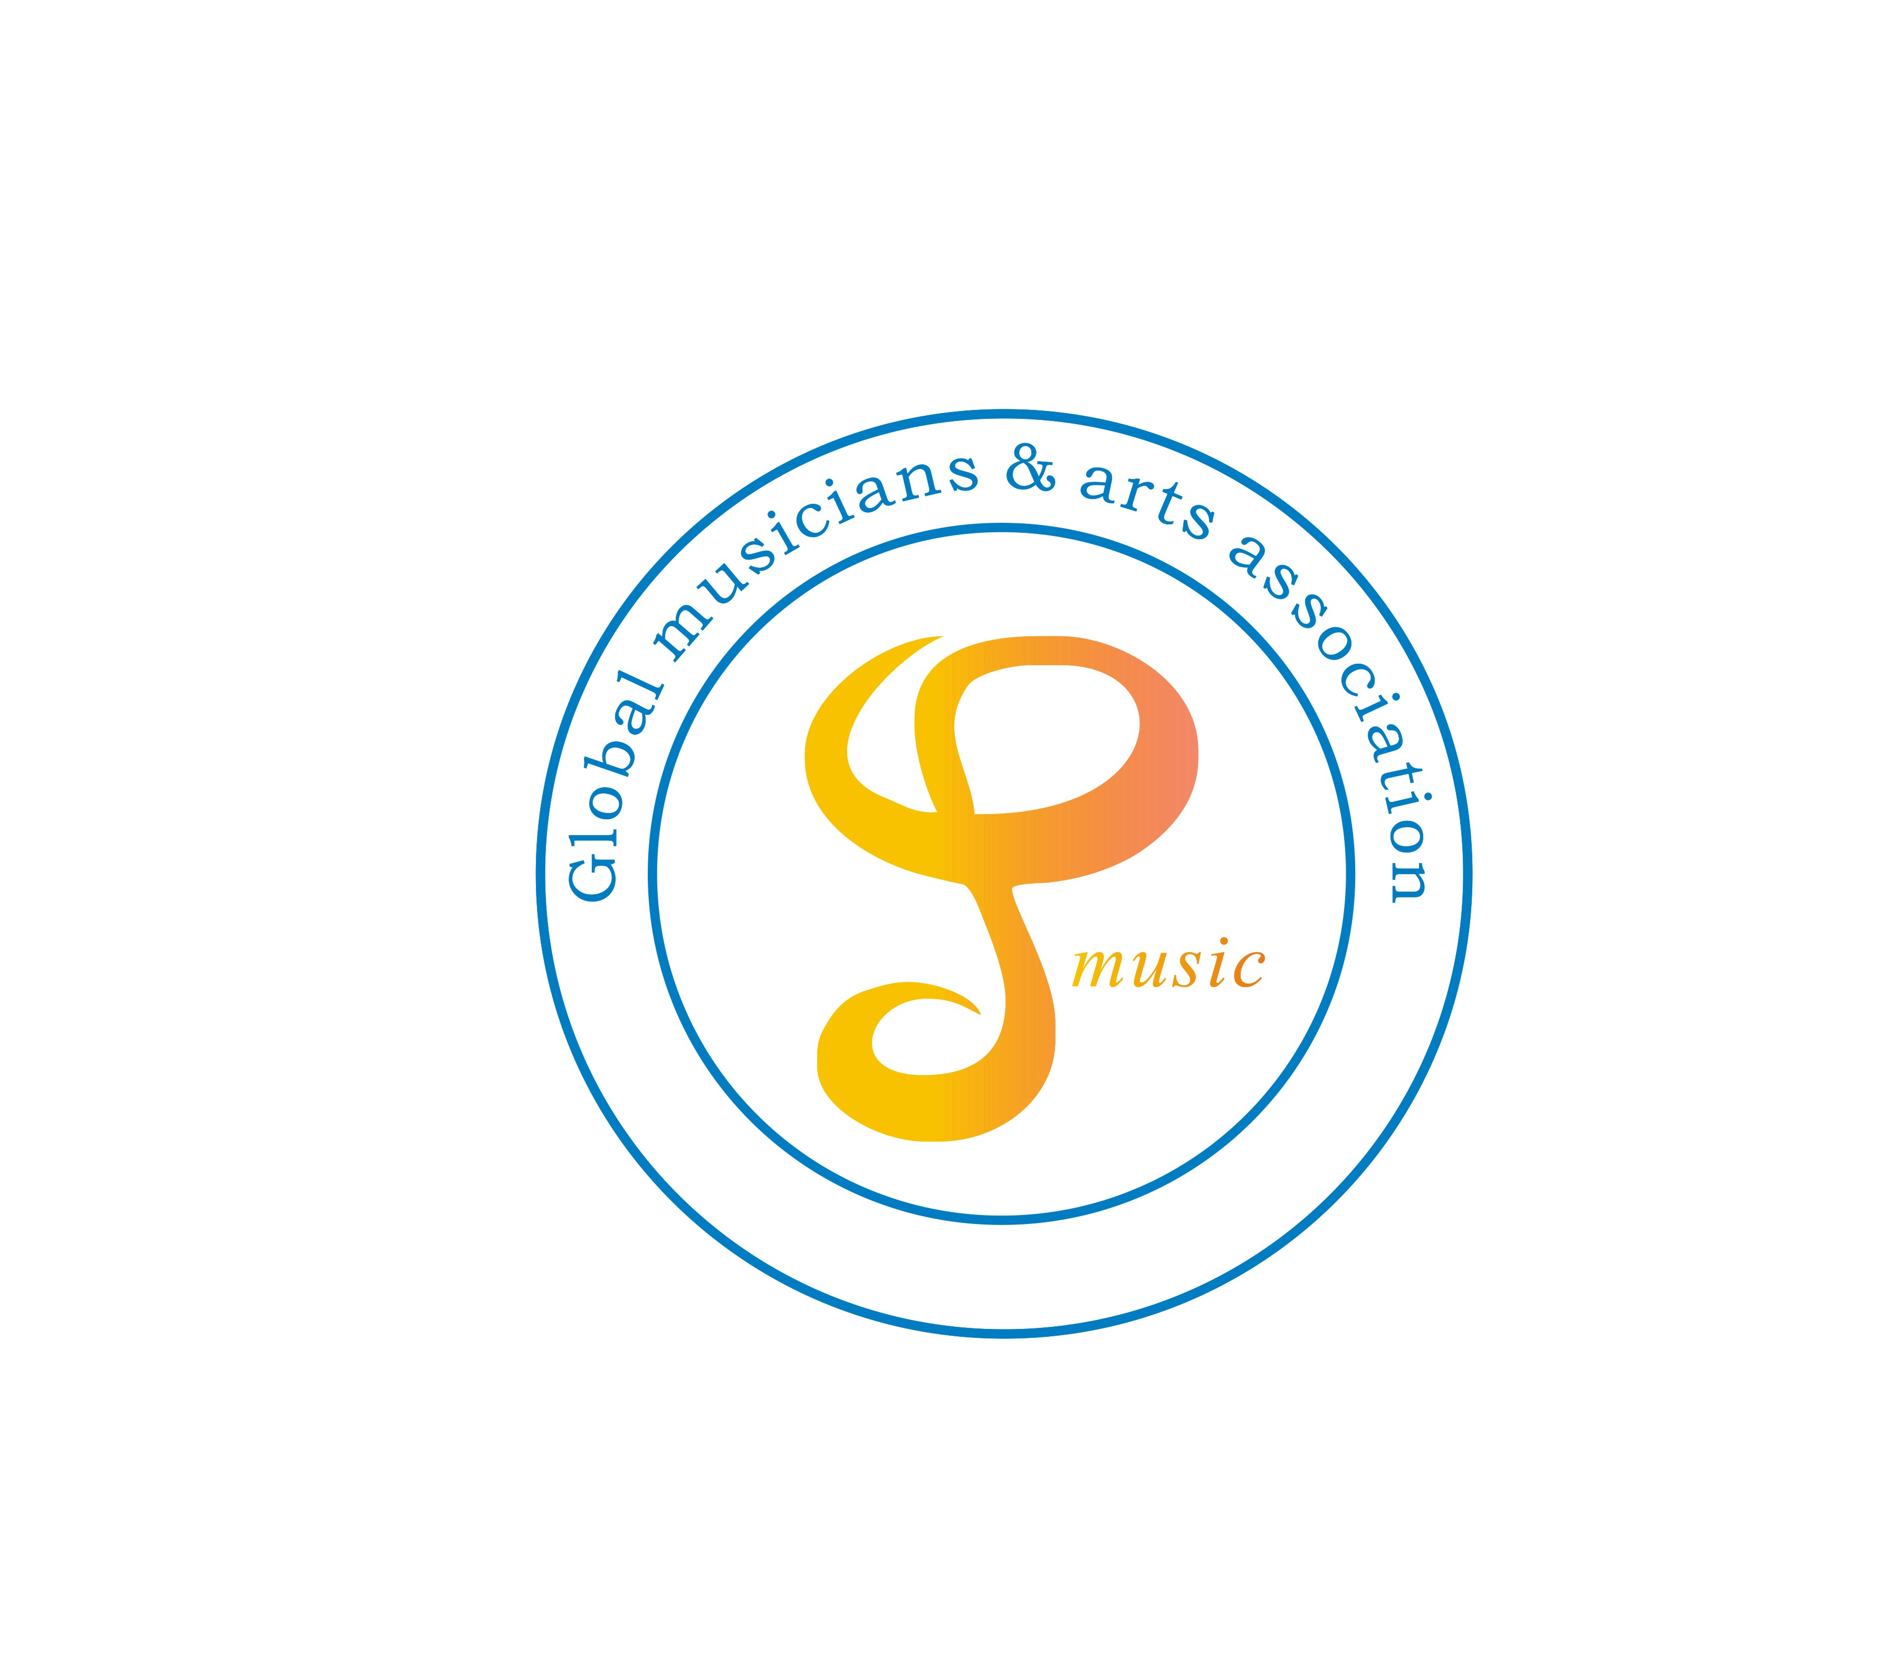 | 6th APEX International Music Competition Application Form  DEADLINE FOR APPLICATION FEB 17, 2025  Live Audition Date: March 16th, 22nd, 23rd, 2025  Audition Address: Raritan Valley Community College Branchburg, NJ  Vera’s Music School Warren, NJ  Raysbrite Institute of Music Princeton, NJ  Music Pathway Studio, NYC | Please mail application form and check payment to:  Global Musicians & Arts Association  226 US Highway 1, Unit M  Edison, NJ 08817  Make Zelle payment to Globalmusicians8@gmail.com
Teacher or Guardian Information:
Name Street address City State Zip code
Telephone Number | E-mail Address
Student Information:
Performer’s Name | Current  Age | Instrument, Voice or Composition | Name of Piece and Composer | Duration  of Piece | Live Audition (Location and date) or Recording | Fee*  included
*Application Fee: $98 for Solo, $76 per person for Duet and group of 3 or above. Please mail the checks with the application forms to the address above.
*For Zelle payment, please send payment to globalmusicians8@gmail.com. Account Name is “Global Musicians & Arts Association”.
*Detailed audition schedule will be issued to applicants two weeks before the Audition date.
*Please use more than one form if more than 10 applicants are entered. Applications who are not attending live auditions shall send an email with a YouTube link of his/her performance to Globalmusicians8@gmail.com by Mar 16th, 2025. Other formats of recording are not acceptable.
*All fees are non-refundable

